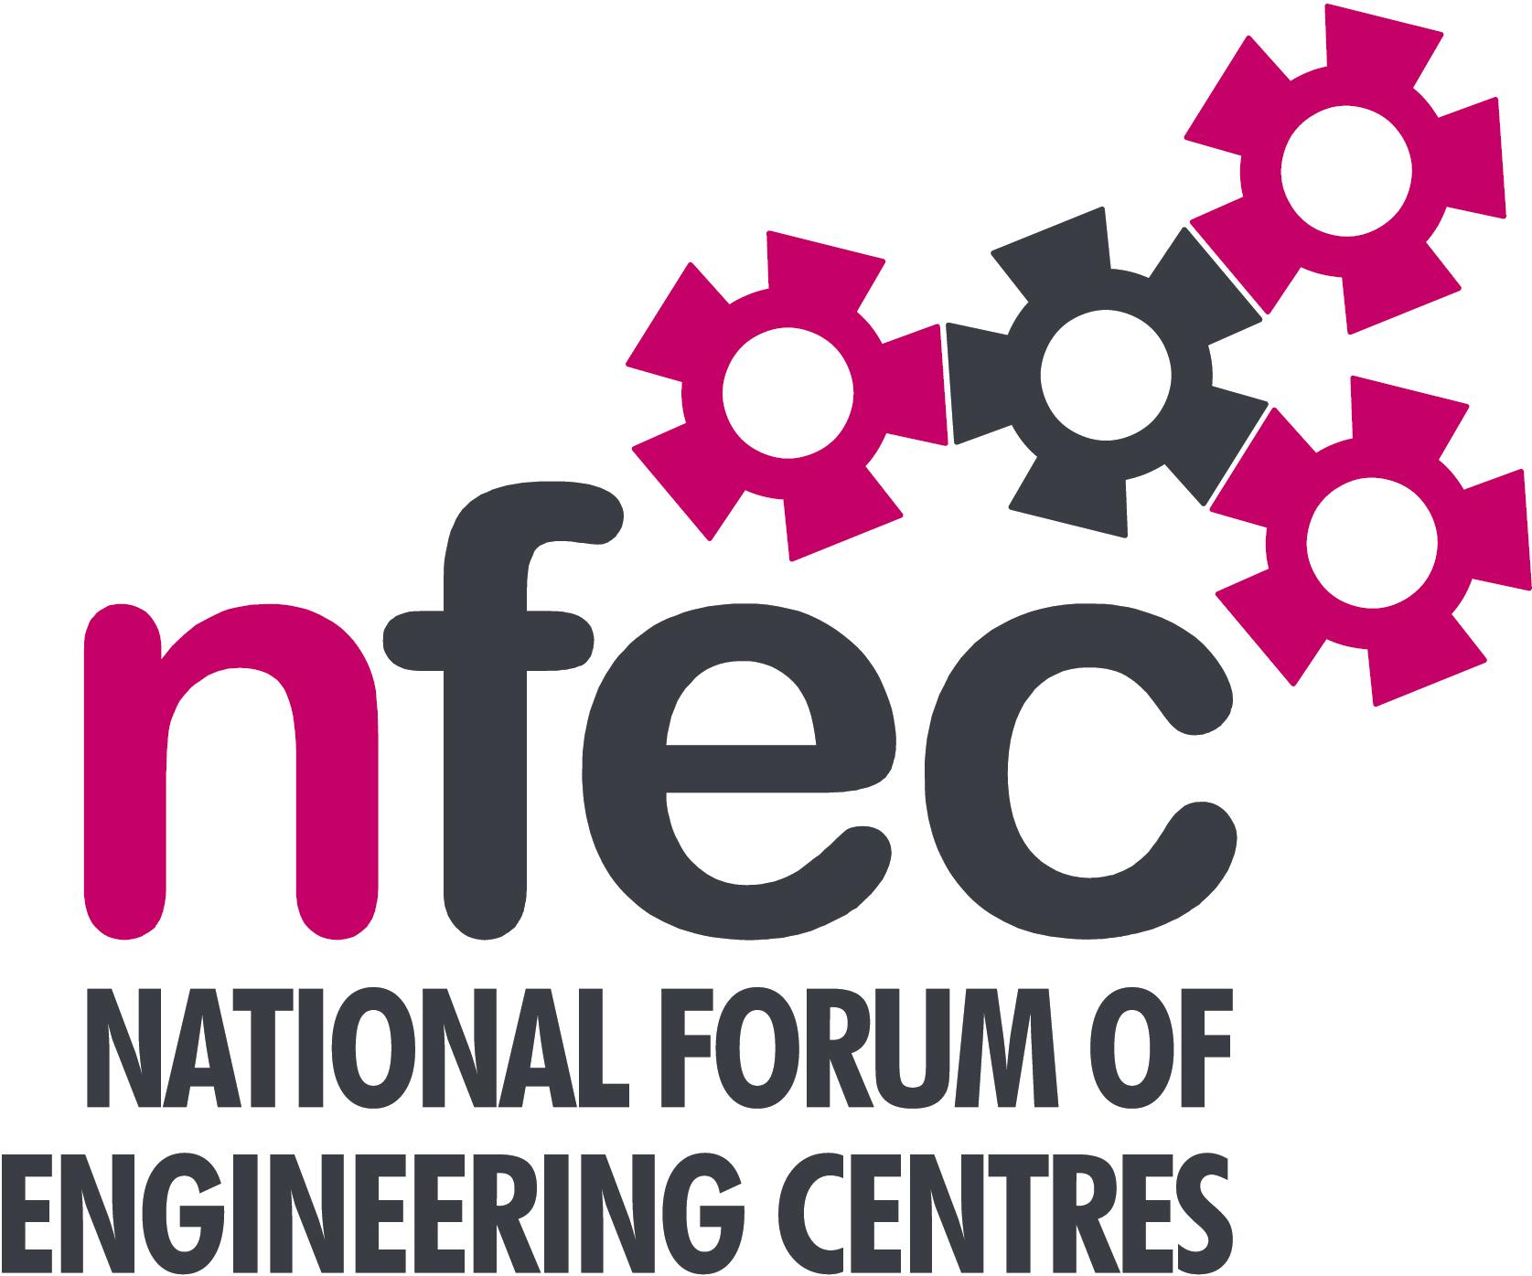
Midlands – NFEC Autumn 2018 Regional Seminar
Host: Birmingham Metropolitan College

Friday 12th October 2018, 10.15am – 15.00 (Coffee from 10.00am)
Venue: Birmingham Metropolitan College (James Watt Campus), Aldridge Road, Great Barr, Birmingham, B44 8NE
Telephone Number: (Kevin Whitehouse) - 0121 360 2087 Mobile: 07941 411466

Programme

- Welcome and Introduction to the Seminar | Kevin Whitehouse (NFEC Midlands Regional Coordinator) and Birmingham Metroploitan College | 10.15
- Current matters of concern relating to quality, content, structure, management and delivery of programmes of training and education in Engineering (not included on Agenda) - an opportunity for open discussion with a focus to distill key issues and plans for addressing them.  - “Know How” Electrical, Electronic Product Service and Installation Engineer (level 3) Apprenticeship  - Discussion around apprenticeships with the Association of Electrical and Mechanical Trades (AEMT)  - Updates from Awarding Bodies – Current developments and general issues. | All Delegates / Kevin Whitehouse  Adrian Smith, Birmingham Metropolitan College  Thomas Marks, AEMT  David Lee, Jason Davis – Pearson  Martin Webber – OCR  Louise Attwood - AQA | 10.20  10.50  11.20  11.40
- BMW Apprenticeships and experience of Gateway assessments: Presentation by two BMW Apprentices outlining their experiences.  Lunch & Demonstrations by Exhibitors  - Discussion around Apprenticeships  Tour of facilities and “Know How” academy  - Plenary session – Issues to note and agreed actions for NFEC  - Date, Place and Topics for next Seminar  Close | Birmingham Metropolitan College  All Delegates  Kevin Whitehouse / Delegates  Kevin Whitehouse / Delegates | 12.15  13.00  13.45  14.30  14.45  15:00
Entry is free to this seminar for members or non-members present for a first attendance.There will be a charge for non members after this. A light buffet lunch will be provided and you will be able to see/discuss demonstrations of the latest available equipment and facilities for the delivery of learning in Engineering | To book your place: Email: admin@nfec.org.uk  Phone: 07759 901229

